Slide 1



.

Slide 2

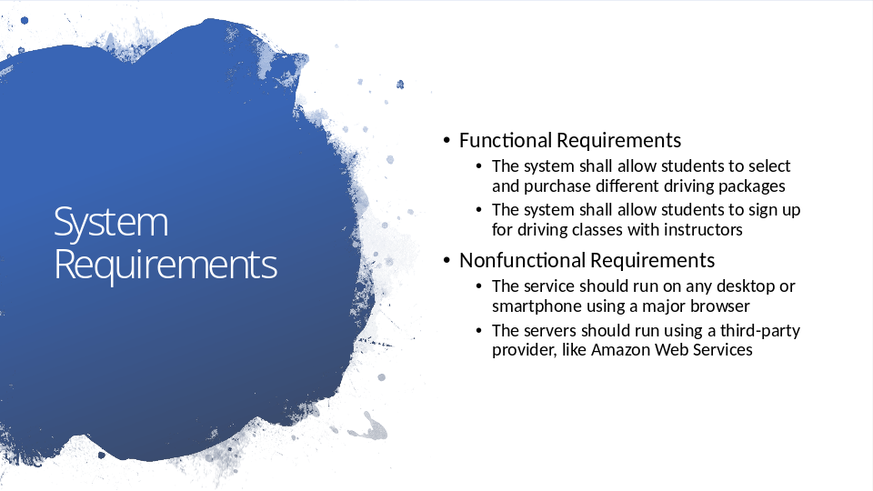
System requirements are what we expect the website to do. System requirements are broken down into functional and nonfunctional requirements. You can think of functional requirements like actions someone can do with the website, like login to their account, or purchase a driving package – it’s things you can do. Nonfunctional requirements are things you expect from the website that aren’t necessarily actions you take, like it loading fast, or being protected from hackers.

This design has a lot of requirements, but I’ve highlighted what I think are some of the most important requirements. In the functional requirements category:
- Students should be able to sign up and pay for their driving packages. In an age of convenience, customers expect the ability to pay for your service through an online portal.
- Students should also be able to sign up for driving classes with instructors. This means they can see your instructors open time slots and request to be picked up and dropped off at certain locations.

In the nonfunctional requirements category:
- This service should be accessible to anyone using a computer at home or their own smartphone. Instead of downloading an app, they will interact with DriverPass through a website. The benefit of using a design like this is that it reduces the time and cost of developing an app for every different kind of phone and computer.
- The server technology for this design uses a third-party provider. This means we pay someone else to run the application on their servers. The benefit of this is that your company doesn’t have to hire staff to maintain the servers, purchase your own servers, or find the space for a secure server room
Slide 3

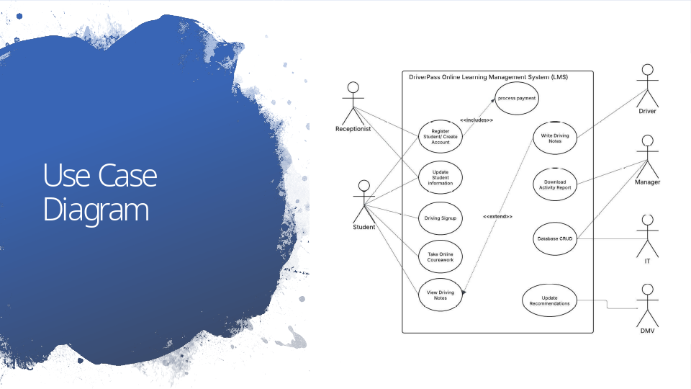
This is a Use Case diagram. This is meant to create a big-picture idea of who uses the service and what they do while they’re on the website. Based on our previous interviews, here is who I think we need to keep in mind while building this website and the core things the website needs to do:

- The receptionist (secretary)
- Should be able to help students with registration and payment
- They should also be able to update a student's information, like their name or address
- Students
- Should also be able to create their own account. They will be asked to select a driving package and make a payment at the time of account creation
- They should be able to update their demographic information, like their preferred name, address, pickup/ dropoff location, and credit card information
- They should be able to signup for driving time with an instructor. This means they should see a calendar view of your instructors availability, and should only be able to signup for driving hours they’ve paid for
- They should be able to see feedback their driving instructors have written about them
- They should be able to view your online coursework, which includes taking their practice tests
- Driving instructor
- Your instructors should be able to see who they’ve driven with and write feedback to the students.
- IT staff
- Should be able to manage the website. This means looking at and modifying account activity.
- Manager
- Should be able to manage the website. This might mean creating new IT accounts, viewing account activity, and deleting accounts.
- Should be able to download a report from the database for offline editing
- DMV
- Data should be pulled directly from the DMV website for your coursework and practice tests.

Slide 4

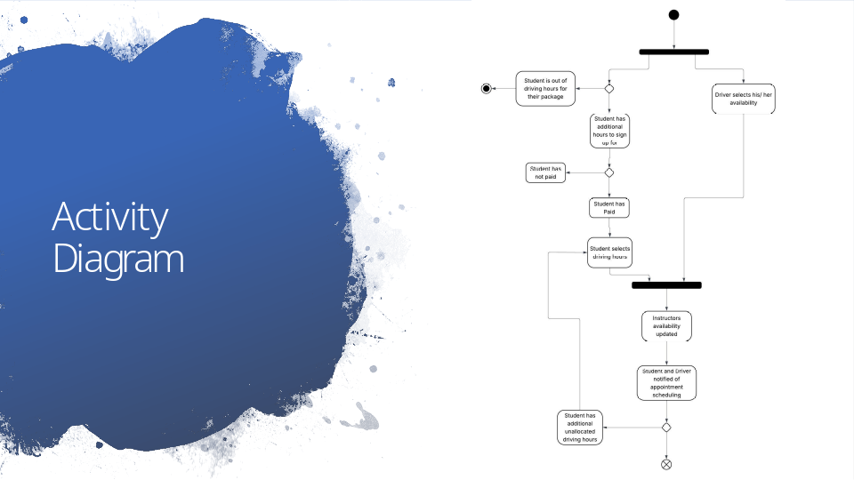
This is an activity diagram. It describes the steps an engineer takes to make the website works. Importantly, it mirrors the steps you want your business to take when it’s doing a task. This is so we can both be on the same page about how the website is supposed to behave. This diagram describes how students sign up for lessons with one of your driving instructors. To start, either you or the driver lets the website know what days and times they are available. Then, when a student tries to sign up for a time slot, the website takes the following steps:
- It checks that the student has hours available to signup for a timeslot. For example, if a student has paid for 8 hours on the road and has signed up for 6 hours of driving time, they can sign up for one more 2 hour timeslot
- The website then checks that the student has paid for their driving hours
- The student then chooses what timeslot to signup for
The website then updates the instructor's availability. This is so your instructors aren’t double booked. Then both the student and the driving instructor are notified that the appointment was created. Letting users know when something successfully happened is an important part of preventing frustration and miscommunication. If the student has more hours to sign up for, the website will let them go back to sign up for more driving hours. Otherwise, the activity is complete.

Slide 5

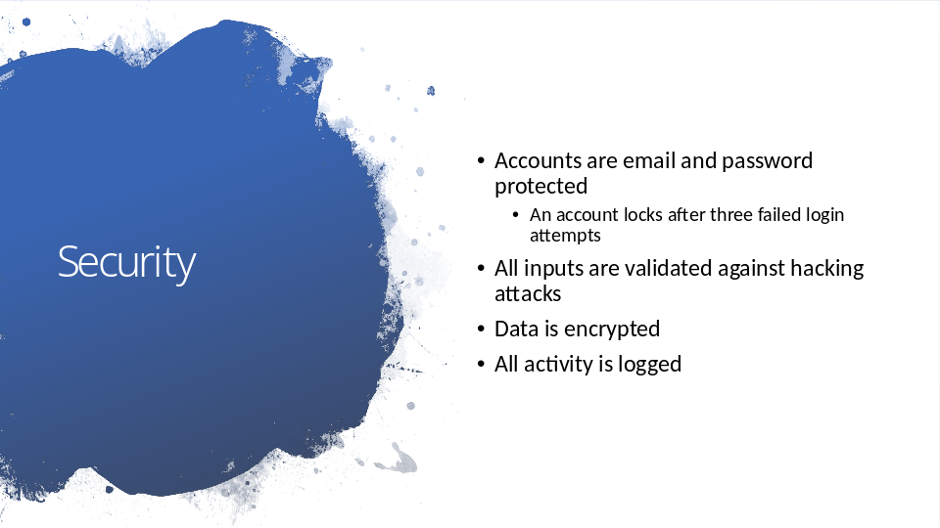
Because your website stores people's personal data, like their address and credit card information, it’s important that implement security measures on the website.
- The first security measure, and the one you’re most likely to be familiar with, is that you need to use an email and password to login to the website. This means that everyone can only see information that is relevant to themselves. Additionally, your students and employees accounts should lock and require a password reset after three failed login attempts. Hackers can use a tool that guesses every possible password in a matter of minutes, so it’s important to stop them from guessing the correct one.
- The next security measure is that the website checks everything anyone sends to it. This means that a student shouldn’t be able to type “give me everyones credit card information” into the login screen and get everyone's credit card information.
- We’re also planning to encrypt everyone's data. If you’re not familiar with encryption, this means jumbling up the data so it’s unreadable to anyone who doesn’t know how to unjumble it. The way to unjumble the data is always unique to the business, so it makes it difficult for someone who steals our information to understand it.
- The website should also record everything anyone does. Despite our best efforts, security breaches are always possible. After a security breach happens, it’s important we can track down what happened, who did it, and notify the correct people of any damages that was done to them.
- Another security benefit we have is that we’re planning on using a third-party provider for our servers. These providers already have security in place, which means that hackers can’t just walk into the server rooms and take what they want.

Slide 6

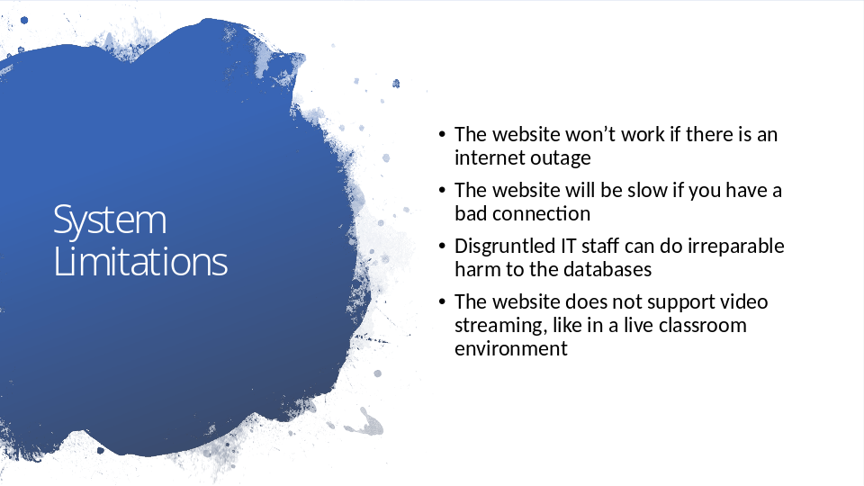
It’s important we also address what the website can’t do and any potential harm that can be done from the website.
- Because this is a website, both your students and staff won’t be able to work if there’s any kind of interruption to the internet. In that instance, your business could come to a complete halt.
- Similarly, the website could become frustratingly slow to use if you have a bad internet connection, or there’s a server outage.
- We also plan on giving both you and your IT staff a lot of power over the website. This means that a mistake, or disgruntled staff member, could do a lot of harm to your business. An example of this would be someone deleting all the drivers' appointments or leaking your students credit card information.
- You may have heard of companies like Zoom or Skype during the COVID19 pandemic. A lot of schools used these video chatrooms to host their classes. The website doesn’t have that.

